Department of Wyoming news December 2020
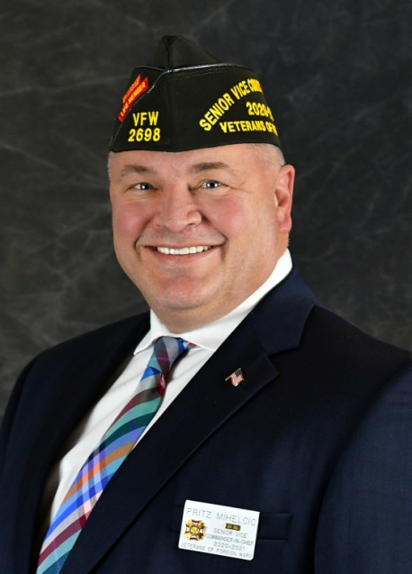
Matthew M. “Fritz” Mihelcic succeeded to the
Senior Vice Commander in chief
of the Veterans of Foreign Wars of the U.S.
on July 24, 2020.

Post Charter Anniversaries
Star Valley Post 4797 – 12/16/1945
Fremont Peak Post 12/08/1945
November 900 Club winners
$500 – Ticket 51 – Don Neville – sold by Post 9439
$300 – Ticket 2 – Ray Cassell – sold by Lee Yake
$100 – Ticket 134 – Jim Bush – sold by Jim Rush

VFW Deadlines for 2020-2020
Voice of Democracy, Patriot’s Pen, Teacher Packages should be at District and must be judged and sent to Department Chairman by December 15. January 1 – Public Servant (Firefighter, Law Enforcement, EMT) to Post. March 1 – Scout Packages due to Post April 15 – Post Special Project, Community Service Post. May 15 – All Community Service, Citizenship and Youth Activities reports.
Mid-Winter convention has been Move to 12th and 13th of February. Covid is raising hell in that part of the state so the decision has been made to move. Please contact your hotel and make sure that the dates get changed.
VFW Department of Wyoming Email: qm@vfwwy.org
1480 E. Sunlight Drive Website: vfwwy.org
Casper, Wyoming
Phone: 307-514-5087 Cell: 307-253-0278

